***Lecture Four − Parametric Equations and Polar Coordinates***

***Section* 4.1 – Parameterizations of Plane Curves**

***Definition***

If *x* and *y* are given as functions



Over an interval *I* as *t*−values, then the set of points  defined by these equations is a ***parametric curve***. The equations are ***parametric equations*** for the curve

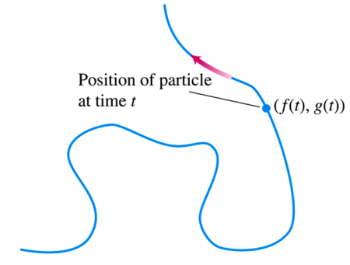

The variable *t* is a parameter for the curve, and its domain *I* is the parameter interval.

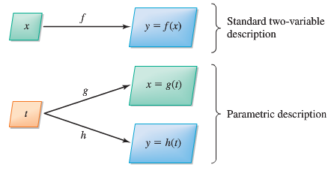

***Definition***

The direction in which a parametric curve is generated as the parameter increases is called the forward or positive orientation of the curve.

***Example***

Sketch the curve defined by the parametric equations



Then obtain an algebraic equation in *x* and *y*.

**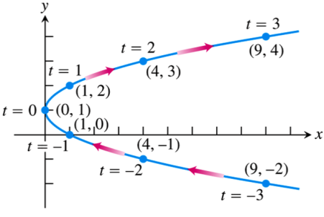*Solution***

|  |  |  |
| --- | --- | --- |
| *t* |  |  |
| −3 | 9 | −2 |
| −2 | 4 | −1 |
| −1 | 1 | 0 |
| 0 | 0 | 1 |
| 1 | 1 | 2 |
| 2 | 4 | 3 |
| 3 | 9 | 4 |



 ***represents a parabola***

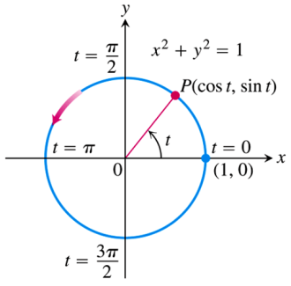***Example***

Graph the parametric curve 

***Solution***



This parametric curve lies along the unit circle .

As t increases from 0 to 2π, the point  starts at (1, 0) and traces the entire circle once counterclockwise.

***Example***

Graph the parametric curve 

***Solution***



This parametric curve lies along the unit circle .

As *t* increases from 0 to 2π, the point  starts at (*a*, 0) with a radius  and traces the entire circle once counterclockwise.

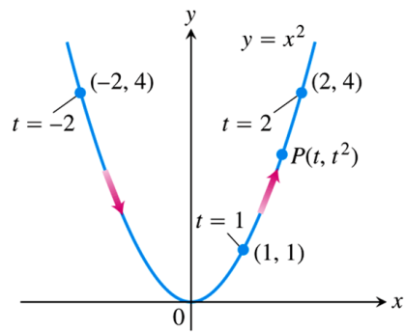***Example***

Graph the parametric curve 

***Solution***



***Example***

Find a parameterization for the line through the point (*a*, *b*) having slope *m*.

***Solution***

A Cartesian equation of the line is 

If 



That is, 

***Example***

Sketch the curve defined by the parametric equations 

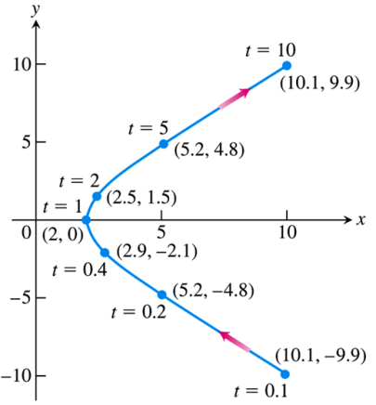Then obtain an algebraic equation in *x* and *y*.

***Solution***

|  |  |  |
| --- | --- | --- |
| *t* |  |  |
| .2 | 5.2 | −4.8 |
| .5 | 2.5 | −1.5 |
| 1 | 2 | 0 |
| 2 | 2.5 | 1.5 |
| 5 | 5.2 | 4.8 |





***Cycloids***

The problem with a pendulum clock whose bob swings in a circular arc is that the frequency of the swing depends on the amplitude of the swing.

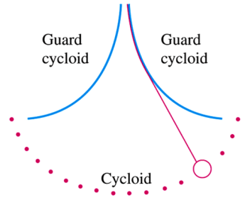

***Example***

A wheel of a radius *a* rolls along a horizontal straight line. Find parametric equations for the path traced by a point P on the wheel’s circumference. The path is called a cycloid.

***Solution***

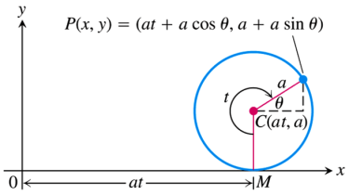 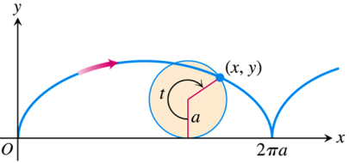

We take the line to be on the *x*-axis, mark a point *P* on the wheel, start the wheel with *P* at the origin, and roll the wheel. As parameter, we use the angle *t* through which the wheel turns, measured in radians. The wheel’s center C lies at  and the coordinates of *P* are



To express *θ* in terms of *t,* we observe that , so that 

That makes 



That implies to: 

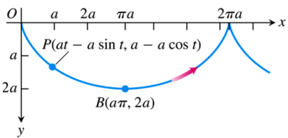 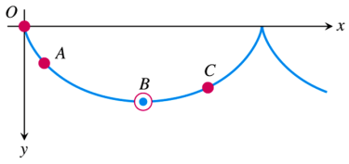

***Exercises*** ***Section* 4.1 – Parameterizations of Plane Curves**

(**1 − 28**) Give parametric equations and parameter intervals for the motion of a particle in the *xy*-plane. Identify the particle’s path by finding a Cartesian equation for it. Graph the Cartesian equation.

|  |  |
| --- | --- |
|  |  |

(**29 − 32**) For the given parametric equations:

1. Plot the following curve, indicating the positive orientation.
2. Eliminate the parameter to obtain an equation in x and y.
3. Identify or briefly describe the curve.
4. Evaluate  at the specified point.
5. 
6. 
7. .
8. 

(**33 − 47**) Find parametric equations:

1. For the left half of the parabola , originating at 
2. A line that passes through the points  and , oriented in the direction of increasing *x*.
3. Lower half of the circle centered at  with radius 6, oriented in the counterclockwise direction.
4. Upper half of the parabola , originating at 
5. The circle centered at the origin with radius 4, generated counterclockwise.
6. The circle centered at the origin with radius 12, generated clockwise with initial point 
7. The circle centered at  with radius 1, generated counterclockwise.
8. The circle centered at  with radius 3, generated clockwise.
9. The circle centered at  with radius 8, generated clockwise.
10. The circle , generated clockwise.
11. The upper half of the ellipse , generated counterclockwise.
12. The right side of the ellipse , generated counterclockwise.
13. The line 
14. The line segment from  to  and the line segment from *Q* to *P*.
15. The segment of the curve  from  to 
16. What is the relationship among *a, b, c*, and *d* such that the equations

 describe a circle?

What is the radius of the circle?

1. Find parametric equations (not unique) of an ellipse centered at the origin with major axis of length 6 on the  and minor axis of length 3 on the , generated counterclockwise. Graph the ellipse and find a description in terms of *x* and *y*.
2. Find parametric equations (not unique) of an ellipse centered at the origin with major axis of length 12 on the  and minor axis of length 2 on the , generated clockwise. Graph the ellipse and find a description in terms of *x* and *y*.
3. Find parametric equations (not unique) of an ellipse centered at  with major and minor axes of lengths 30 and 20, parallel to the  and , respectively. Graph the ellipse and find a description in terms of *x* and *y*.
4. Find a parametric equation and a parameter interval for the motion of a particle starting at the point (2, 0) and tracing the top half of the circle  four times.
5. Find a parametrization for the line segment joining points (0, 2) and (4, 0) using the angle *θ* in the accompanying figure as the parameter.

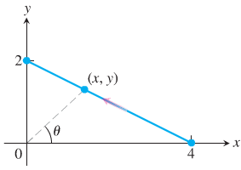

1. Find a parametrization for the circle  starting at (1, 0) and moving counterclockwise to the terminal point (0, 1), using the angle *θ* in the accompanying figure as the parameter.

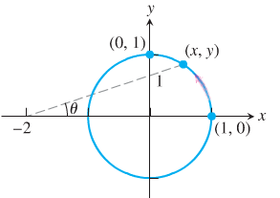

1. A common task is to parameterize curves given either by either Cartesian equations or by graphs. Find a parametric representation of the following curves.
2. The segment of the parabola 
3. The complete curve 
4. The piecewise linear path that connects  to  to  (in that order), where the parameter varies over the interval 
5. A projectile launched from the ground with an initial speed of 20 *m/s* and a launch angle *θ* follows a trajectory approximated by



Where *x* and *y* are the horizontal and vertical positions of the projectile relative to the launch point .

1. Graph the trajectory for various of *θ* in the range .
2. Based on your observations, what value of *θ* gives the greatest range (the horizontal distance between the launch and landing points)?
3. Many fascinating curves are generated by points on rolling wheels. The path of a light on the rim of a rolling when is a cycloid, which has the parametric equations



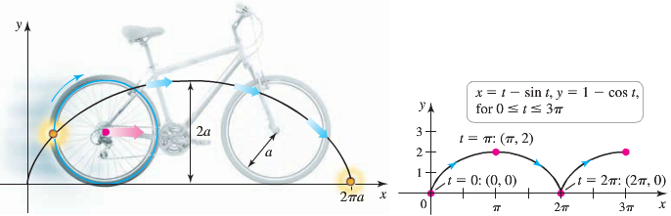

Where . Graph the cycloid with . On what interval does the parameter generate one arch of the cycloid?

(**58 − 60**) Find parametric equations that describe the circular path of the objects. Assume  denotes the position of the object relative to the origin at the center of the circle.

1. A go-cart moves counterclockwise with constant speed around a circular track of radius 400 *m*, completing in 1.5 *min*.
2. The tip of the 15-*in* second hand of a clock completes one revolution in 60 *sec*.
3. A Ferris wheel has a radius of 20 *m* and completes a revolution in the clockwise direction at constant speed in 3 *min*. Assume that *x* and *y* measure the horizontal and vertical positions of a seat on the Ferris wheel relative to a coordinate system whose origin is at the low point of the wheel. Assume the seat begins moving at the origin.
4. A plane traveling horizontally at 80 *m/s* over flat ground at an elevation of 3000 *m* releases an emergency packet. The trajectory of the packet is given by

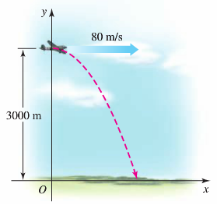



Where the origin is the point on the ground directly beneath the plane at the moment of the release. Graph the trajectory of the packet and find the coordinates of the point where the packet lands.

1. A plane traveling horizontally at 100 *m/s* over flat ground at an elevation of 4,000 *m* must drop an emergency packet on a target on the ground. The trajectory of the packet is given by



Where the origin is the point on the ground directly beneath the plane at the moment of the release.

How many horizontal meters before the target should the packet be released in order to hit the target?

1. The path of a point on circle *A* with radius  that rolls on the inside of circle *B* with a radius *a* is an asteroid or hypocycloid. Its parametric equations are

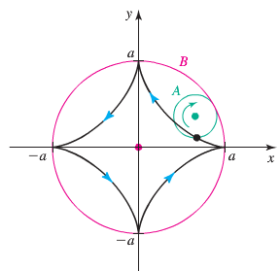



Graph the asteroid with  and find its equation in terms of *x* and *y*.